|  |  |
| --- | --- |
| Team ID | PNT2022TMID38280 |
| Project Name | AI - powered Nutrition Analyzer for Fitness Enthusiasts |

**1 Image Preprocessing**

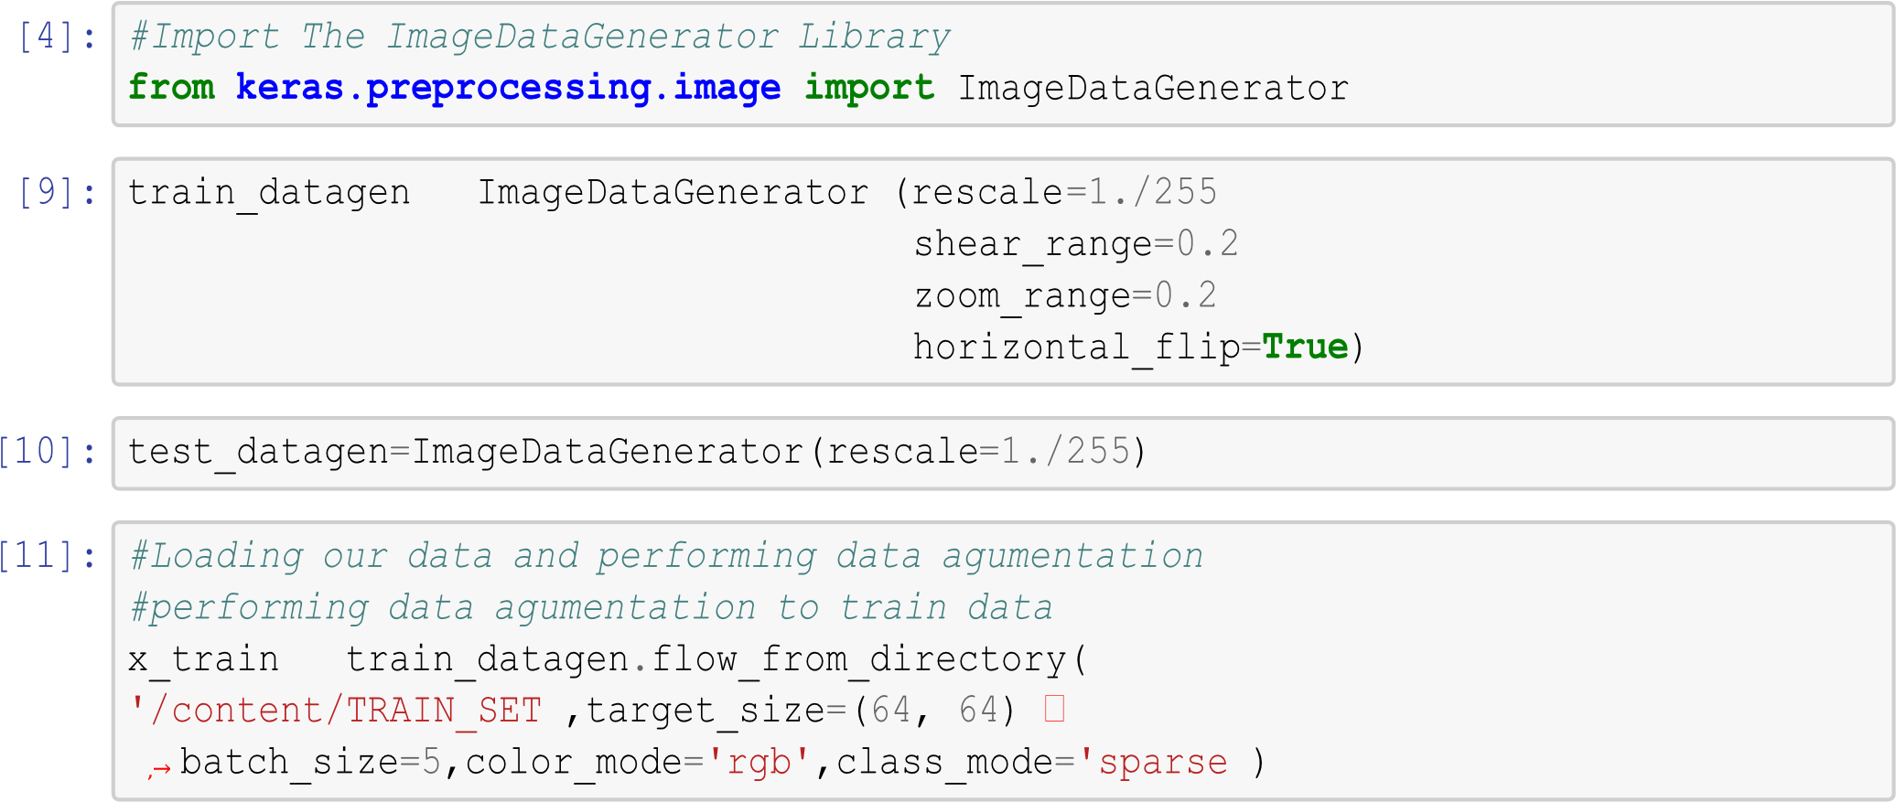

Found 2626 images belonging to 5 classes.

[12]: *#performing data agumentation to test data* x_test = test_datagen.flow_from_directory('/content/TEST_SET',target_size

=(64,␣

*,*→64), batch_size=5,color_mode='rgb',class_mode='sparse') Found 1055 images belonging to 5 classes.

[13]: print(x_train.class_indices) *#checking the number of classes*

{'APPLES': 0, 'BANANA': 1, 'ORANGE': 2, 'PINEAPPLE': 3, 'WATERMELON': 4}

[14]: print(x_test.class_indices)*#checking the number of classes*

{'APPLES': 0, 'BANANA': 1, 'ORANGE': 2, 'PINEAPPLE': 3,

'WATERMELON': 4}



[15]: Counter({0: 606, 1: 445, 2: 479, 3: 621, 4: 475})